**IT252 Assignment-2**

NAME: SUYASH SATISH CHINTAWAR

ROLL NO.: 191IT109

TOPIC: SQL – DDL CONSTRAINTS

* Tables used from previous database:

1. student_courses 2)student_info

|  |  |  |  |
| --- | --- | --- | --- |
| sname | sid | cname | cid |
|  |  |  |  |

|  |  |  |
| --- | --- | --- |
| sname | sid | dept |
|  |  |  |

3)course_list

|  |  |
| --- | --- |
| cname | cid |
|  |  |

* Dummy Tables used for ON DELETE and ON UPDATE:

1)books 2)authors

|  |  |
| --- | --- |
| book_id | book_name |
| Primary key |  |

|  |  |  |
| --- | --- | --- |
| auth_id | auth_name | book_id |
| Primary key |  | Foreign key |

NOTE: Output screen shots contain schema of all above tables and their content. Screenshots have been attached in the zip folder.

* Screenshots for all commands:

NOTE: “set default” in on delete/on update couldn’t be used because engine was set to “InnoDB” which doesn’t support on delete/on update set default.

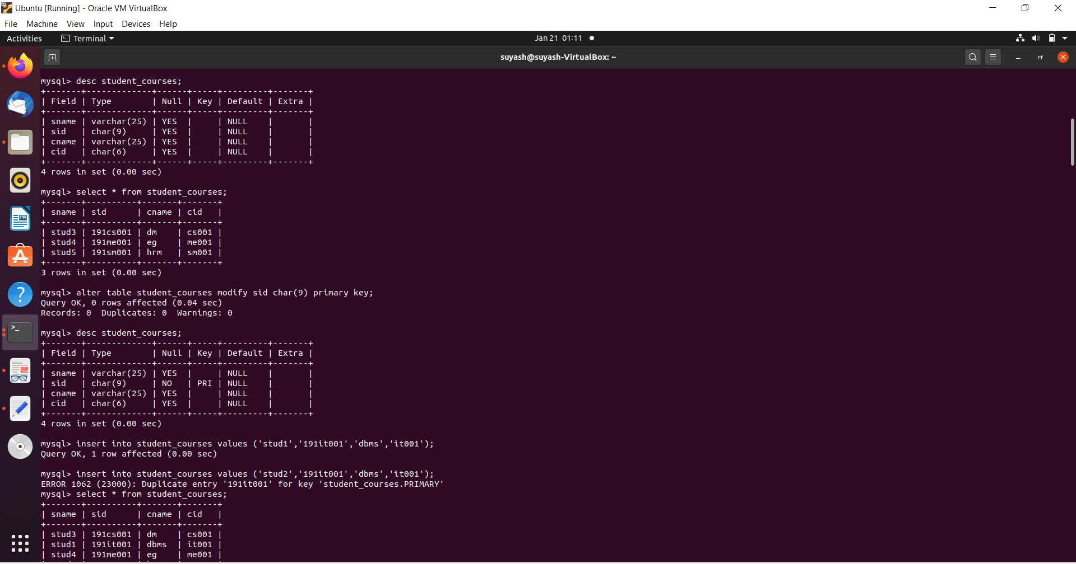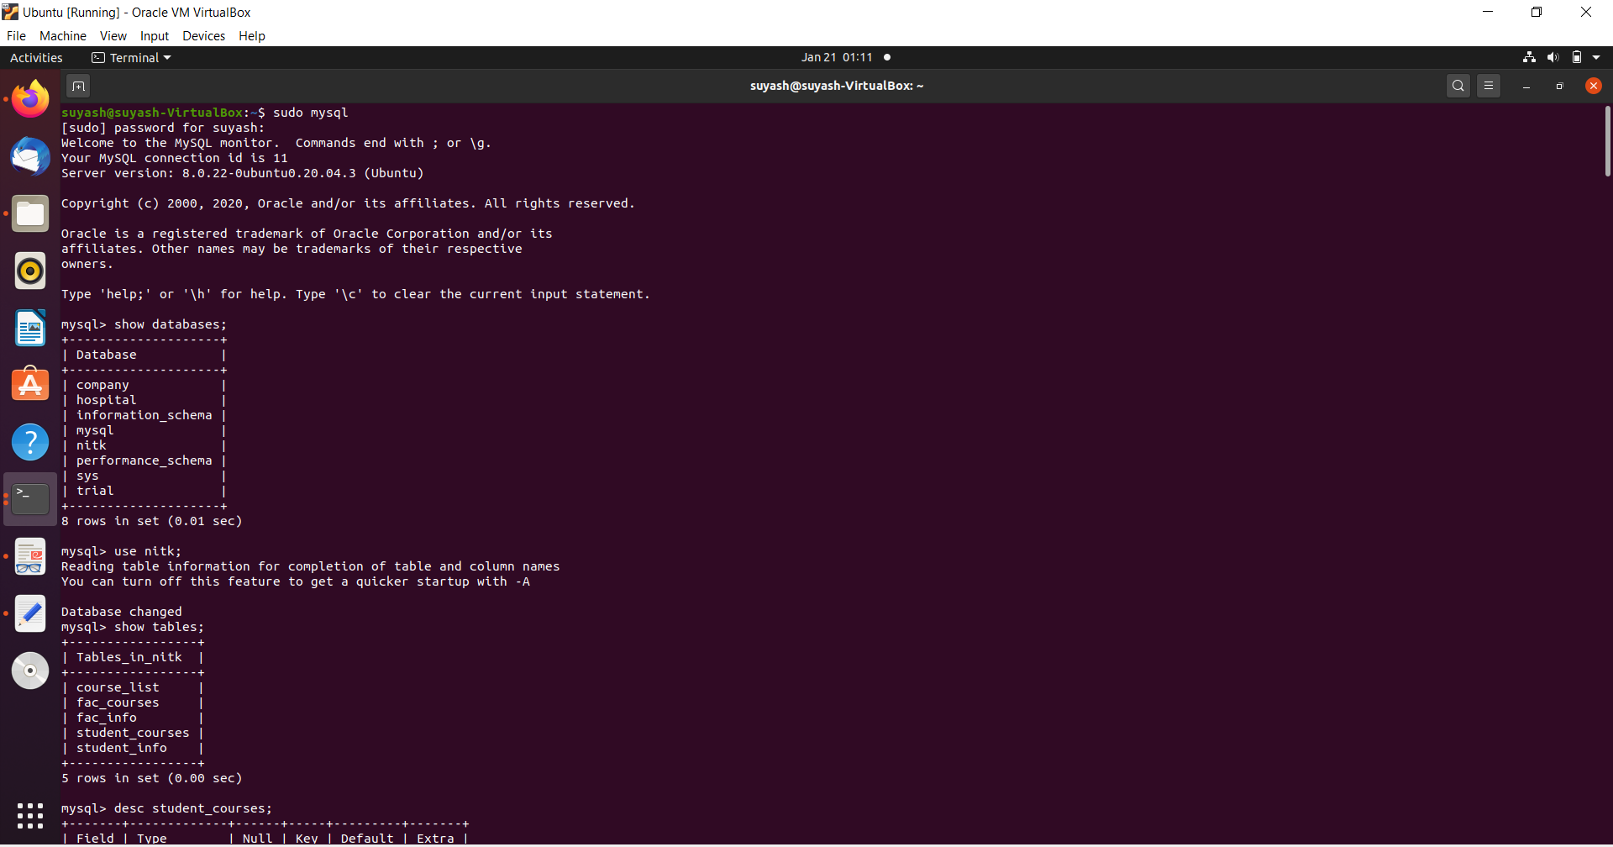

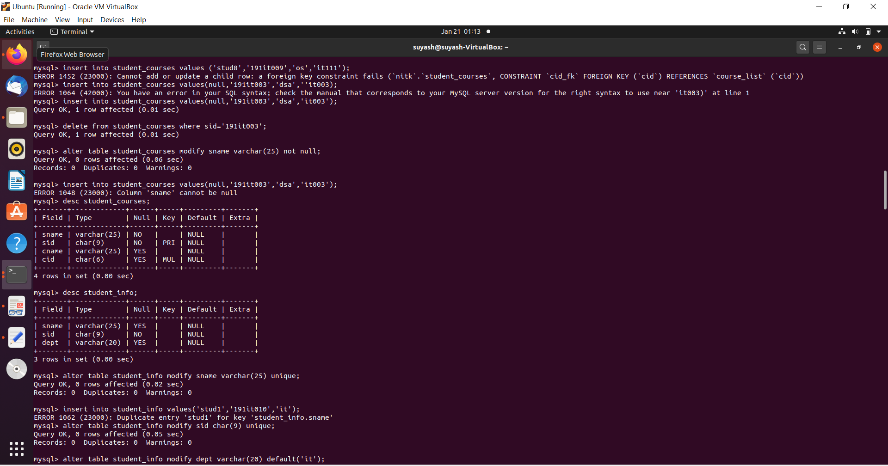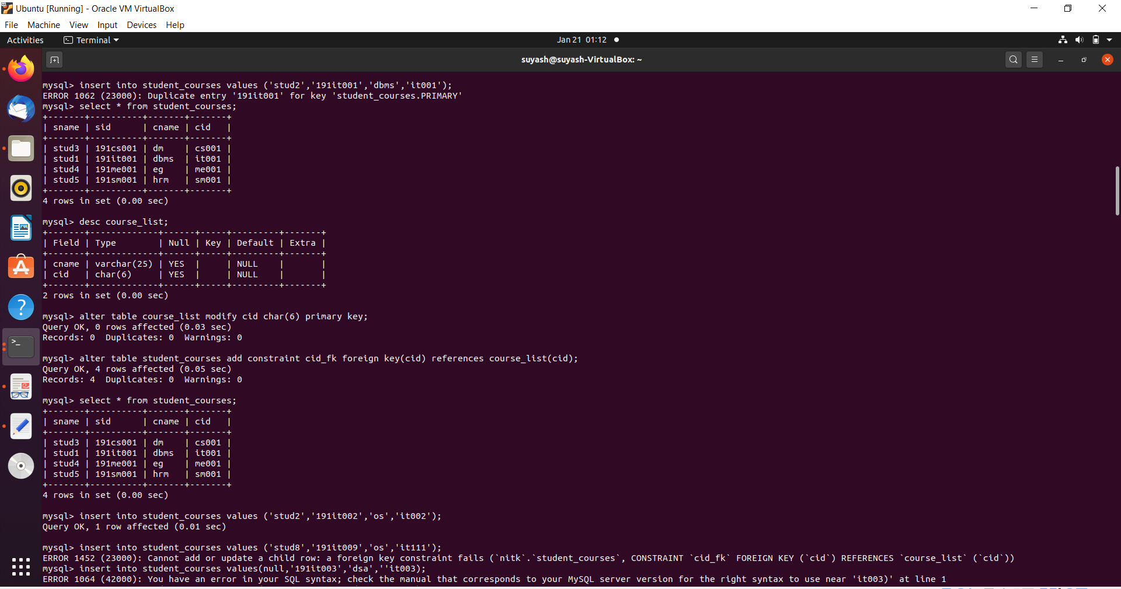

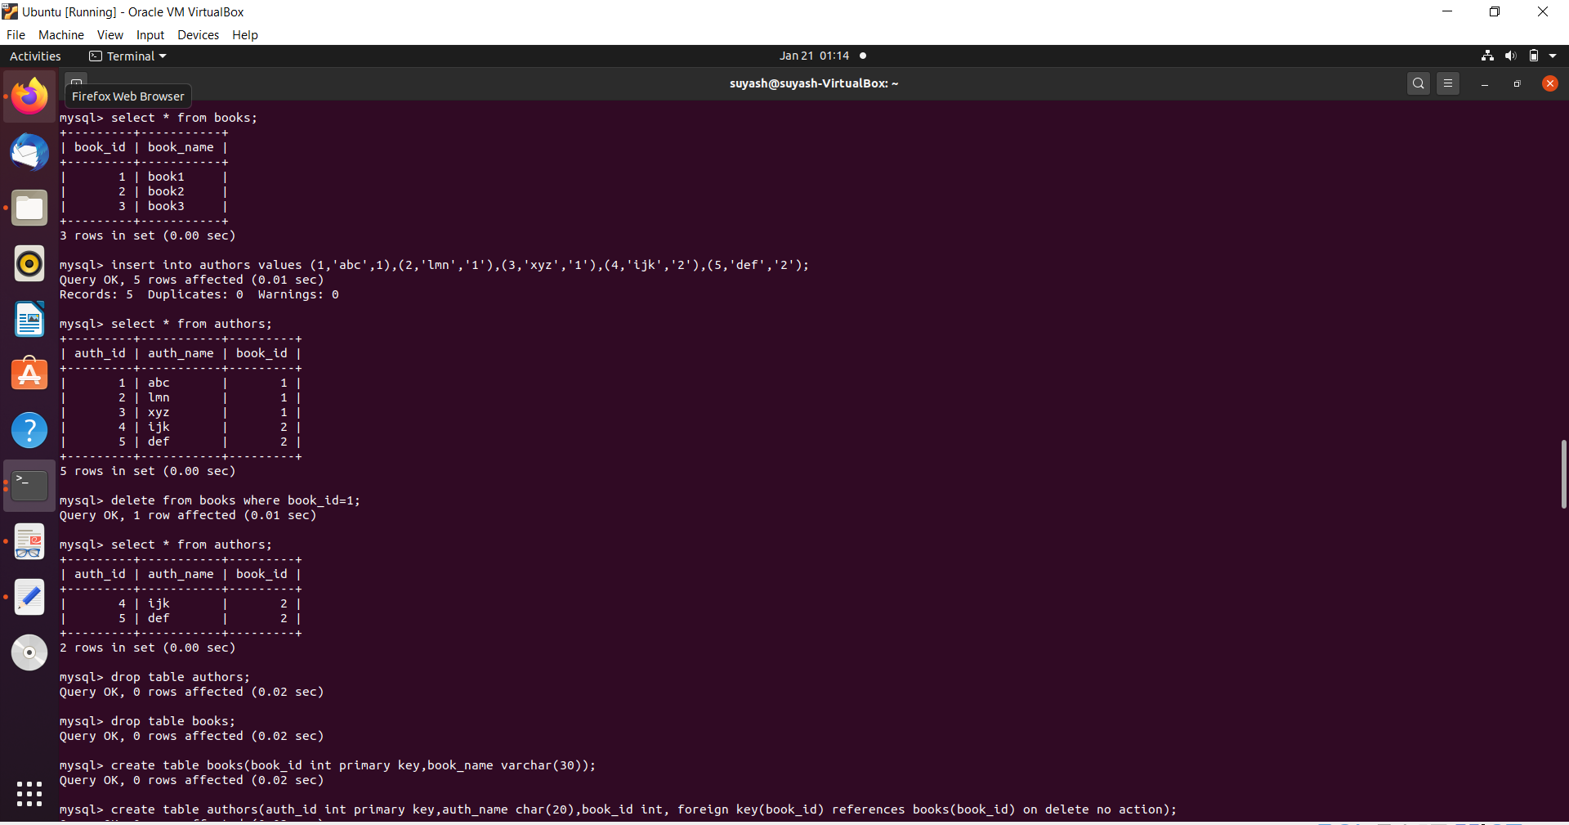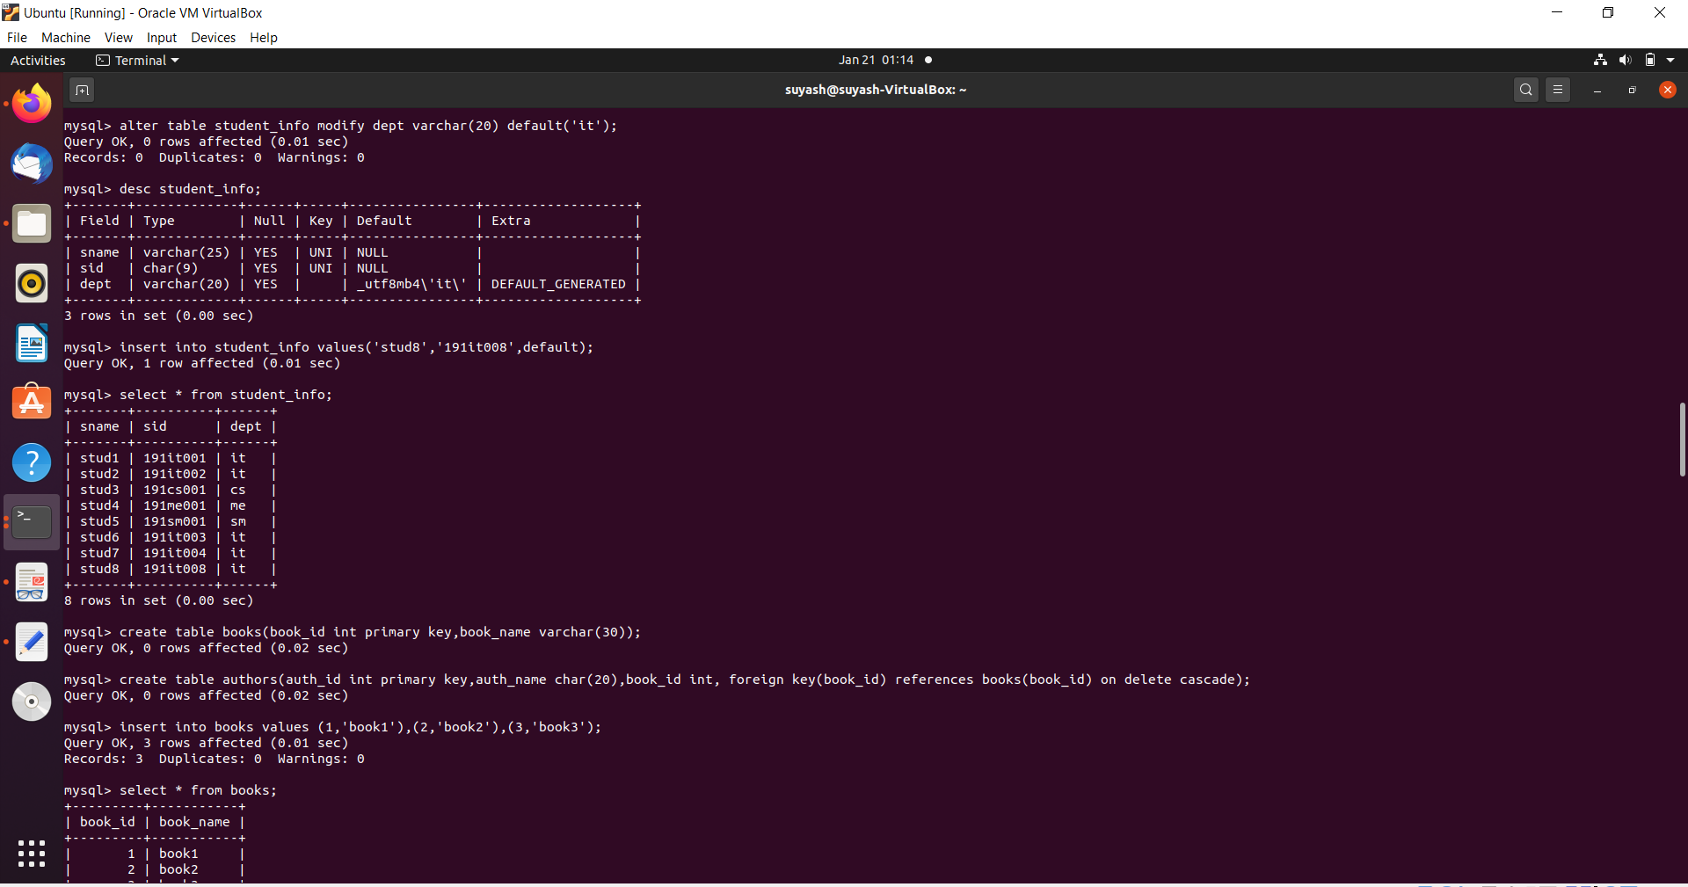

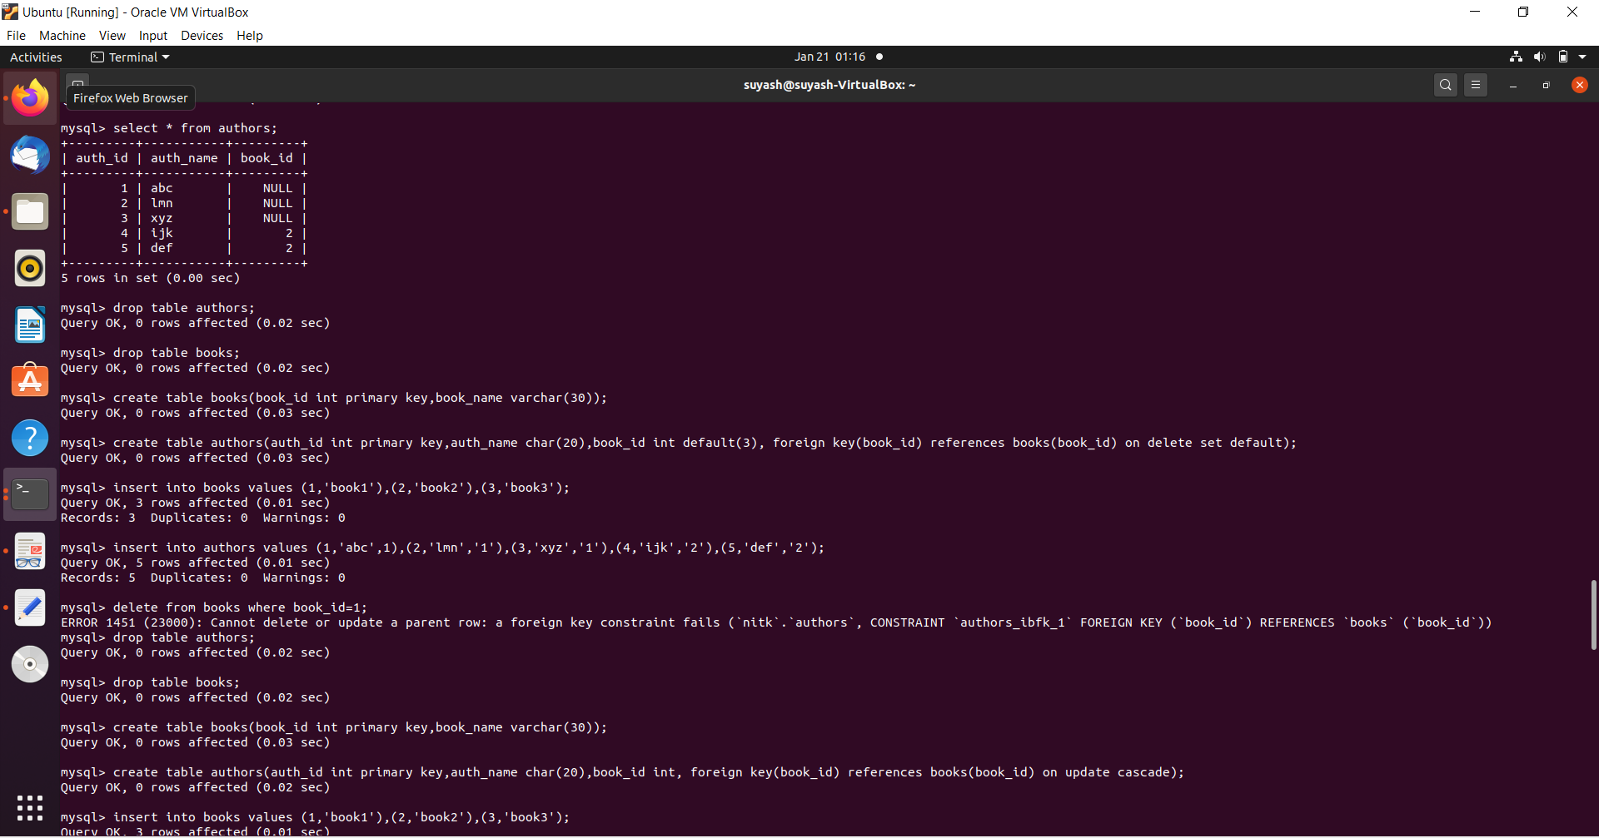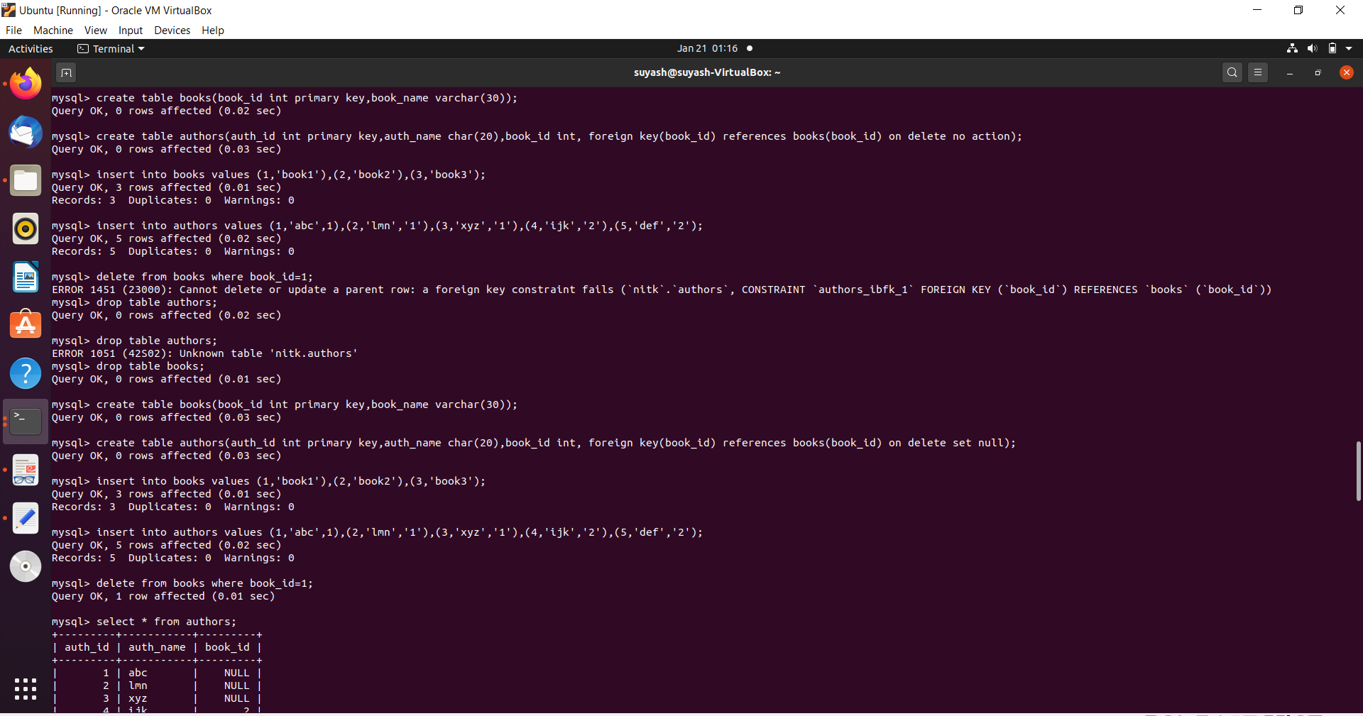

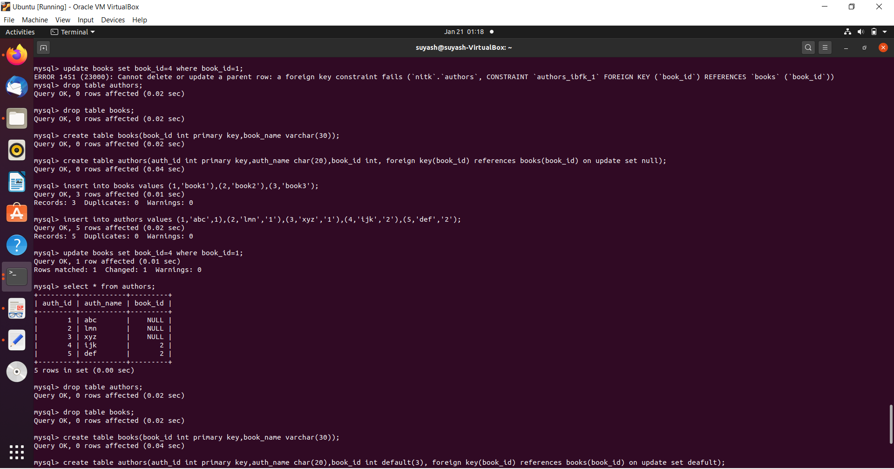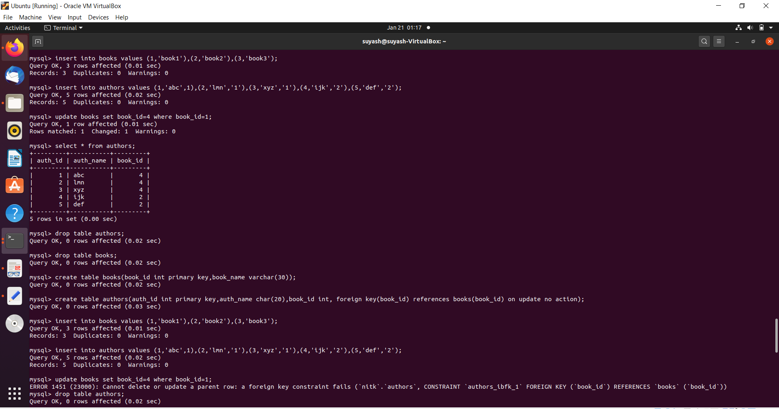

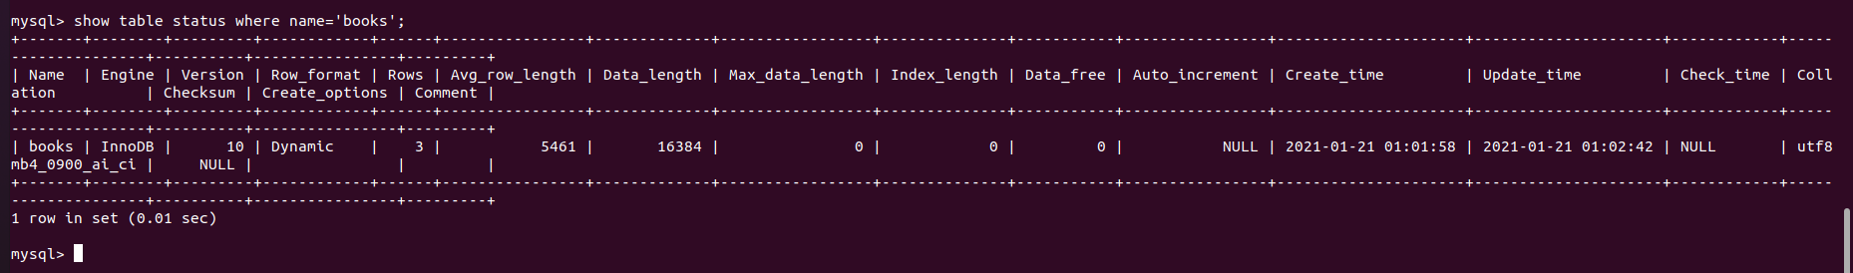

* 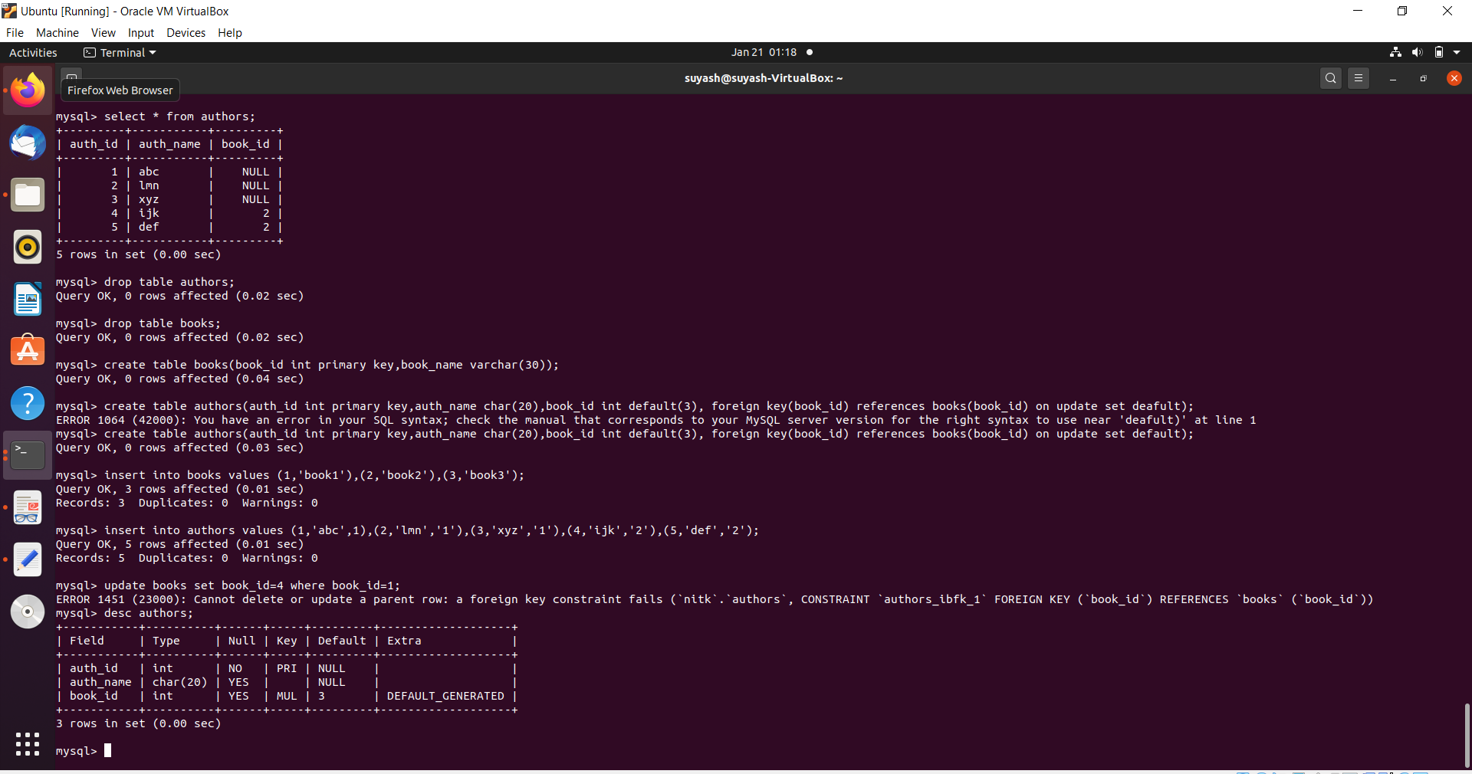Picture above shows an example the default engine used by the tables, i.e. InnoDB.